Master in Informatics and Computing Engineering

Databases  
Professor Carla Alexandra Teixeira Lopes

C:\Users\Maria Ferreira\AppData\Local\Microsoft\Windows\INetCache\Content.Word\logo.png

Hospital management

Architecture Definition Document

Group 207:

Bernardo José Coelho Leite - up201404464

Francisco Tomé Macedo Martins Santos Moreira - up201607929

Rita Ferreira Carvalho - up201304918

**Abstract**

The management of a hospital define its efficiency degree. In this way, we intend to implement a database that allows the management and appointment of consultations in a hospital so that it can improve its services and making it more efficient

Summary

1. Introduction 1

1.1. Problem overview 1

2. Data flow 2

1.2. Context 2

1.3. Class Diagram 3

1. Introduction

This document summarizes the work done in the Databases class of the second year of MIEIC.

The second section relates the data flow where we explain what we intend to do and the UML diagram according the Conceptual Model.

* 1. Problem overview

In this work we intend to develop the UML model according the Conceptual Model and demonstrate the context of the database we intend to develop in the next assignments.

1. Data flow

It’s important to show the data flow of the work context to better understanding the better way to develop the database.

* 1. Context

For the context of this work we intend to develop a platform that computerizes the marking and management of appointments and examinations of a hospital to invigorate the existing system in the hospital.

In order to achieve this, it is necessary to develop a database containing all the information necessary for medical appointments and / or examinations.

In this way, an appointment will be referenced by its time of completion, the name of the patient, the name of the doctor, the day, the start and finish hour. An appointment has only one patient and only one doctor.

The accomplishment of a consultation can afford the marking of an average examination, being that this one is defined by the type of examination, time of accomplishment, the appointment involved and the resultant medical report of the examination. The exam room is defined by the type of exam.

Patients, doctors and functionaries still must be managed, so persons are identified by their name, date of birth, tax identification number, telephone and type of person. If a person is a patient it is also identified by a medical history record and the possession or not of a health insurance. If it’s a doctor is identified by a specialty and a week schedule in the hospital. Every person and every doctor can have multiples appointments but an appointment only has one person and one doctor. If it’s a functionary is defined by its department or departments and also by its week schedule in the hospital.

Finally, for each specialty there is a head of service who directs the medical team of the specialty in question.

* 1. Class Diagram

The context of the solution that we intend to implement is described in the figure above according the Conceptual Modal.

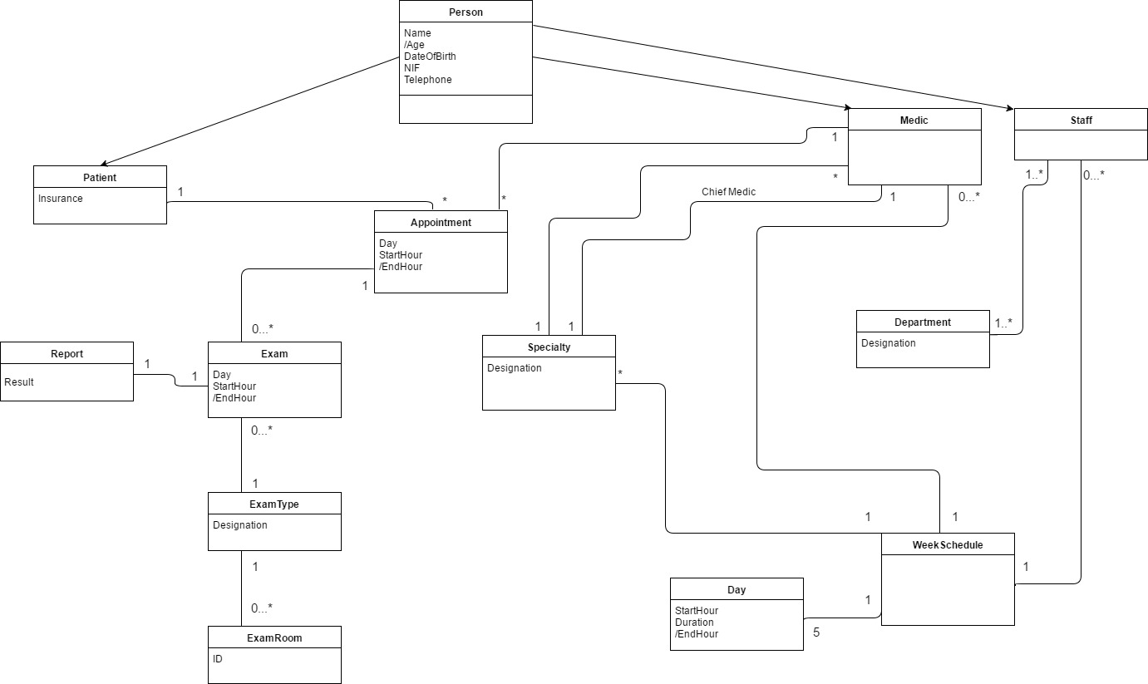

Figure - UML according Conceptual Model